**CONCRETE COMPREHENSIVE STRENGTH PREDICTOR(CCSP)**

**USING MACHINE LEARNING**

**1.Purpose to development of CCSP 4. Work Plan for development 7.Finished product**

* 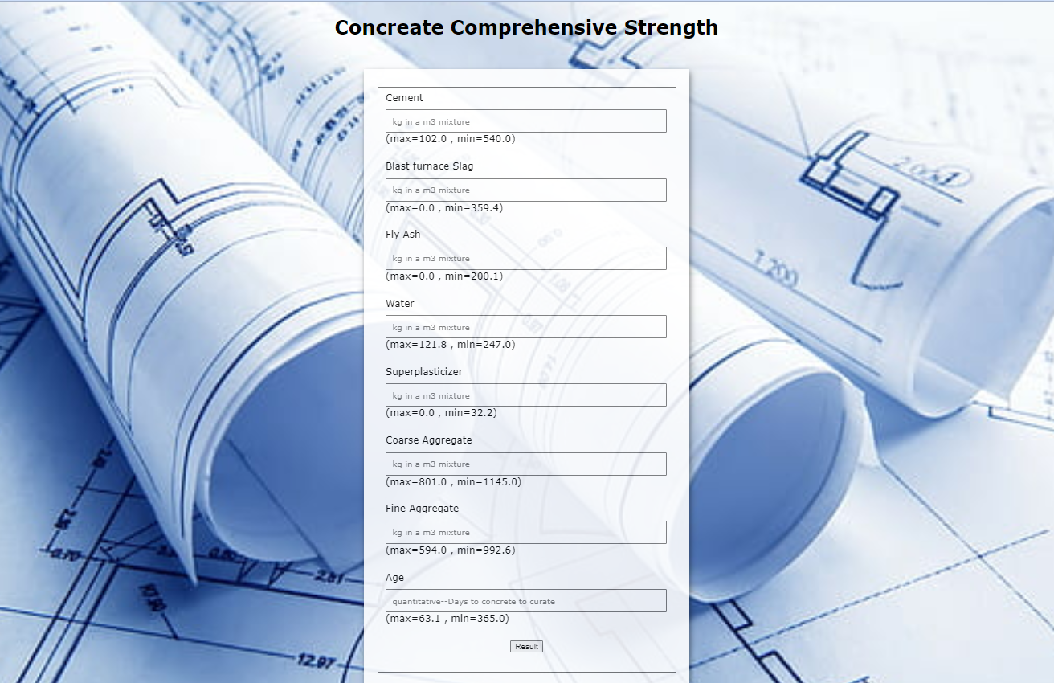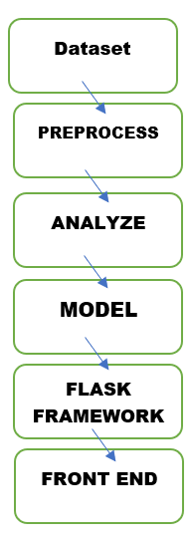It is very difficult to Calculate the concrete comprehensive

strength by Manually.

* So, our predictor system helps the civil

engineers to easily predict their concrete strength using features

like amount of materials added to it.

**2.Product introduction**

* Concrete is the most important material in civil engineering. The

concrete compressive strength is a highly nonlinear function of

age and ingredients.

* These ingredients include cement, blast furnace slag, fly ash,

water, superplasticizer, coarse aggregate, and fine aggregate. **5.Dataset**

* 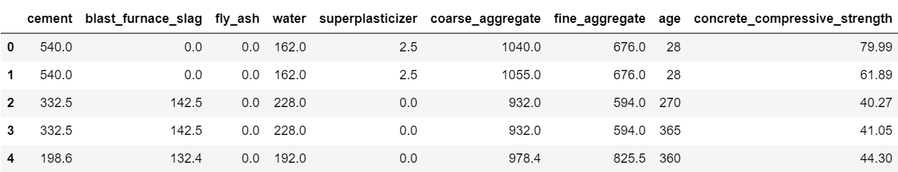It is very hard and almost impossible to Calculate the concrete

comprehensive strength by Manually.

* With the help of machine learning and with proper preprocessing,

we predict the comprehensive strength with the given features .

**8.Cost of product**

* This is entirely build on opensource libraries with free of cost. So, our cost of the product is 0
* But , when we want to deploy this product in cloud services like aws or azure. It costs around 35$

**3.Product explanation**

* The dataset is taken from the Kaggle platform.
* Convert the dataset into a dataframe using pandas. And

Preprocess the dataset .Analyze the dataset using some data

**9.Student involved**

visualization libraries 6.Flask framework

* 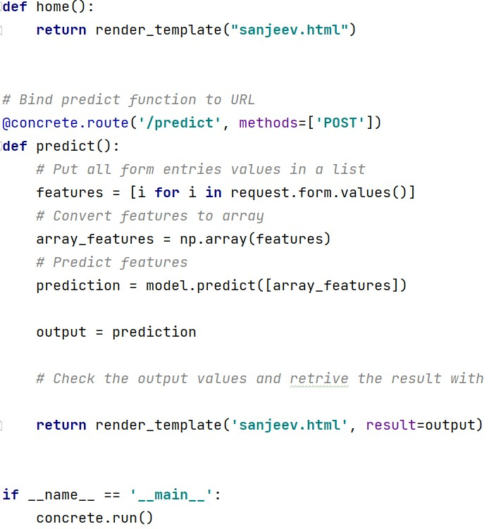We use random forest regressor algorithm . And trained and tested

**SANJEEV KUMAR M**

**201CS272**

the algorithm using our dataset . And optimize the model better

accuracy.

* We created the framework using flask .To give the new input values to

Machine learning model

**10.Outcome of product**

* Product is presented in epoch’22 and won 3rd prize